AIE425 Intelligent Recommender Systems, Fall Semester 25/26

Assignment 1: Neighborhood CF & Clustering in CF

221101140 NOURELDEEN AHMED MAHER MESBAH: Section 1 & Section 3 part 1
221101573 Yousef mohamed Abdelwhab: Section 2 part 2 & section 3 part 3
221101030 yousef zakaria sobhy: Section 2 part 1 & section 3 part 2

Section 3 part 4 is a shared among all members
2025
Table of Content
Title | Page number
Executive summary | 2
Section 1: Statistical analysis | 4
Section 2: Neighborhood CF Filters | 19
Part 1: User-Based Collaborative Filtering | 19
Part 2: item-Based Collaborative Filtering | 31
Section 3: Clustering-based Collaborative Filters | 36
Part 1: K-means Clustering based on average  number of user ratings | 36
Part 2: K-means Clustering based on average  number of common ratings | 44
Part 3: K-means Clustering based on average  number of common ratings | 52
Part 4: K-means Clustering for cold start | 59
References | 77

Executive summary
This report presents an integrated analysis of Neighborhood-Based and Clustering-Based Collaborative Filtering (CF) methods applied to the Dianping dataset (2.1M ratings, 147k users, 11k items). The study examines key structural properties of the data, evaluates multiple similarity metrics, and analyzes clustering strategies to address sparsity, user bias, scalability, and cold-start limitations.
Section 1 establishes the statistical characteristics of the dataset. Results confirm high sparsity, a pronounced long-tail distribution, and a strong positive rating bias (over 94% of items averaging above 3.0). Users exhibit heterogeneous rating behaviors, underscoring the necessity of bias normalization. Item popularity and user activity levels vary widely, producing divergent overlap structures that influence similarity reliability. These findings highlight the need for significance-aware CF and hybrid strategies when user profiles are limited.
Section 2 evaluates Raw Cosine, Mean-Centered Cosine, and Pearson correlation, each with and without Discounted Similarity (DS). Raw Cosine is shown to be highly susceptible to sparsity, frequently generating spurious similarities. Pearson-based measures successfully correct for user-specific rating scales but become unstable under low co-rating counts. Across all cases, DS emerges as the decisive enhancement, consistently suppressing low-evidence neighbors and stabilizing predictions. Item-Based CF, when combined with mean-centering and DS, yields the most robust and interpretable results, outperforming user-based variants in stability and consistency.
Section 3 investigates clustering as a means of improving computational efficiency and structuring the search space. Clustering by user averages, common ratings, and item popularity all achieve substantial reductions in similarity computations (5–7×) without significant loss of accuracy for well-represented users and popular items. However, clustering exacerbates sparsity effects for long-tail items, where global similarity search remains preferable. In cold-start analyses, popularity-based recommendations outperform CF for users with fewer than five ratings, while users reach stable CF performance at approximately 15 ratings. A hybrid clustering–CF–content framework provides modest accuracy gains and more reliable fallback behavior. Ambiguous cluster assignments (≈23%) motivate distance-weighted multi-cluster membership.
Overall, the results demonstrate that effective recommendation in sparse environments requires combining three elements: bias-corrected similarity (mean-centered or Pearson), significance weighting (DS), and clustering for scalability. A practical system should employ clustering to reduce search space, DS to ensure similarity reliability, and hybrid or popularity-based methods for cold-start users. This integrated approach offers a scalable, accurate, and resilient framework for real-world recommender systems.

Section 1: statistical analysis

  - - used Dianping review dataset :https://lihui.info/file/Dianping_SocialRec_2015.tar.bz2
from Yongfeng Zhang's Collection: http://yongfeng.me/dataset/ which meets the minimum requirements of dataset

  - – Checked dataset scale of rating validity, dataset turned out to already have a scale from 1 to 5 in ratings so no adjustment was needed

Math formula: Valid Rating: 1 ≤ r ≤ 5
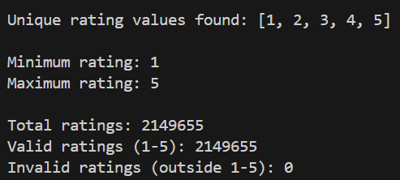

Results Table
Metric | Value
Total Ratings | 2,149,655
Unique Rating Values | [1, 2, 3, 4, 5]
Minimum Rating | 1
Maximum Rating | 5

Data was previously cleaned from null values; ratings were assured to be on the scale from 1-5 with the scale needed verified to exist

  - - Calculated the number of ratings for each user (n_u) and saved it in results section in a CSV file named n_u

Math formula: n_u = COUNT(ratings by user u)
Results table
Statistic Value
Total Users 147,914
Total Ratings 2,149,655
Average Ratings per User 14.53

Analysis & Interpretation
- High Sparsity: Majority of users have rated very few items
- Long-tail Distribution: Few users contribute to total ratings
- Cold Start Problem
- Collaborative Filtering: enough users exist for CF algorithms to be applied

  - - Calculated the number of ratings for each item (n_i) and saved it in results section in a CSV file named n_i

Math formula: n_i = COUNT(ratings for item i)
Results Table
Statistic | Value
Total Items | 11,123
Total Ratings | 2,149,655
Average Ratings per Item | 193.28

  - - Computed the average ratings per user (r_u) and saved it in results section in a CSV file named r_u
Math formula: r̄_u = (Σ r_ui) / n_u
where:
- r_ui = rating given by user u to item i
- n_u = number of items rated by user u
- Σ = sum over all items rated by user u
Analysis & Interpretation
- Positive Bias: Most users likely rate above 3.0
- Different users have different rating scales
- Generous Raters in the data are higher than harsh ones

  - - Computed the average ratings per item (r_i) and saved it in results section in a CSV file named r_i

Math formula : r̄_i = (Σ r_ui) / n_i
where:
- r_ui = rating given by user u to item i
- n_i = number of users who rated item i
- Σ = sum over all users who rated item i
Analysis & Interpretation
- Positive Skew: Most items rated above 3.0 indicating rating bias
- Few Poor Items: Very few items with r̄_i < 2.0

  - - Ascendingly ordered the total number of ratings per item and plotted the distribution per item
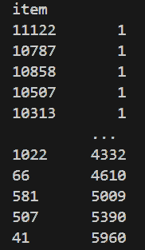
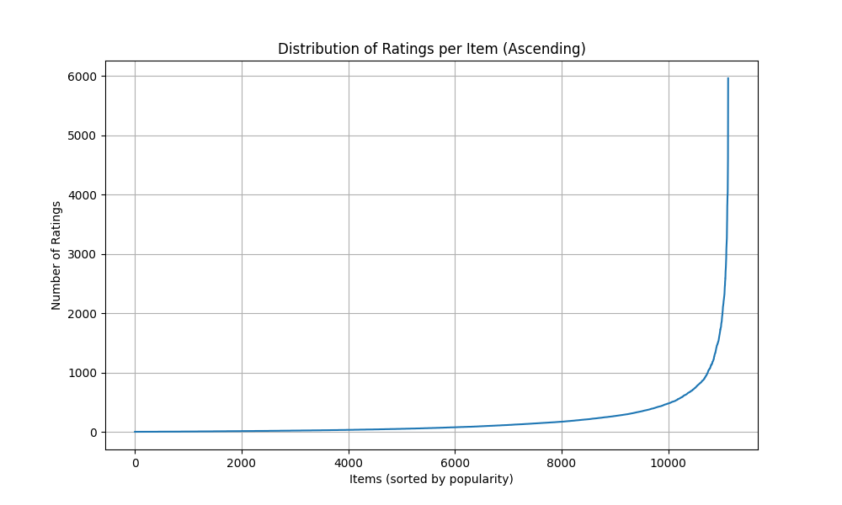
Analysis & Interpretation
- Popularity Variance
- Long-Tail Distribution: Most items have few ratings, few items have many ratings
- Flat Tail: Many items with very few ratings
- Cold Start for Items
- Rich data for popular items

  - – Computed the number of products based on their average ratings and assigned them to groups
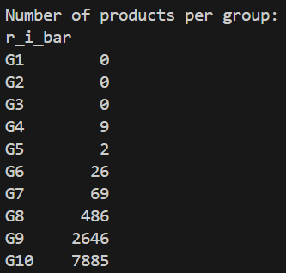

Math formula:
G1: 0% < r̄_i ≤ 1% of 5.0 = 0.00 to 0.05
G2: 1% < r̄_i ≤ 5% of 5.0 = 0.05 to 0.25
G3: 5% < r̄_i ≤ 10% of 5.0 = 0.25 to 0.50
G4: 10% < r̄_i ≤ 20% of 5.0 = 0.50 to 1.00
G5: 20% < r̄_i ≤ 30% of 5.0 = 1.00 to 1.50
G6: 30% < r̄_i ≤ 40% of 5.0 = 1.50 to 2.00
G7: 40% < r̄_i ≤ 50% of 5.0 = 2.00 to 2.50
G8: 50% < r̄_i ≤ 60% of 5.0 = 2.50 to 3.00
G9: 60% < r̄_i ≤ 70% of 5.0 = 3.00 to 3.50
G10: 70% < r̄_i ≤ 100% of 5.0 = 3.50 to 5.00

Results Table
Group | Rating Range | # Items | Percentage
G1 | 0.00-0.05 | 0 | 0.00%
G2 | 0.05-0.25 | 0 | 0.00%
G3 | 0.25-0.50 | 0 | 0.00%
G4 | 0.50-1.00 | 9 | 0.08%
G5 | 1.00-1.50 | 2 | 0.02%
G6 | 1.50-2.00 | 26 | 0.23%
G7 | 2.00-2.50 | 69 | 0.62%
G8 | 2.50-3.00 | 486 | 4.37%
G9 | 3.00-3.50 | 2,646 | 23.79%
G10 | 3.50-5.00 | 7,885 | 70.89%

Analysis & Interpretation
- Extreme Concentration in G10: 70.89% of items rated 3.5-5.0
- Very Few Poor Items: Only 106 items (0.95%) rated <2.5 which means data is positively biased.

  - – Computed the total number of ratings in each group and ordered them ascendingly.
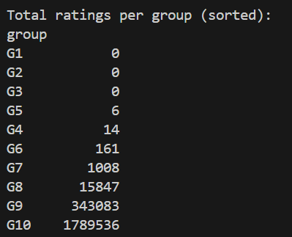

Results Table
Group | Rating Range | # Items | Total Ratings |  | % of Total Ratings
G1 | 0.00-0.05 | 0 | 0 |  | 0.00%
G2 | 0.05-0.25 | 0 | 0 |  | 0.00%
G3 | 0.25-0.50 | 0 | 0 |  | 0.00%
G4 | 0.50-1.00 | 9 | 14 |  | 0.0007%
G5 | 1.00-1.50 | 2 | 6 |  | 0.0003%
G6 | 1.50-2.00 | 26 | 161 |  | 0.0075%
G7 | 2.00-2.50 | 69 | 1,008 |  | 0.0469%
G8 | 2.50-3.00 | 486 | 15,847 |  | 0.7372%
G9 | 3.00-3.50 | 2,646 | 343,083 |  | 15.96%
G10 | 3.50-5.00 | 7,885 | 1,789,536 |  | 83.25%

Analysis & Interpretation
- Users overwhelmingly engage with high-quality items

  - - Plot the distribution of the number of ratings in each group before and after ordering

Before:
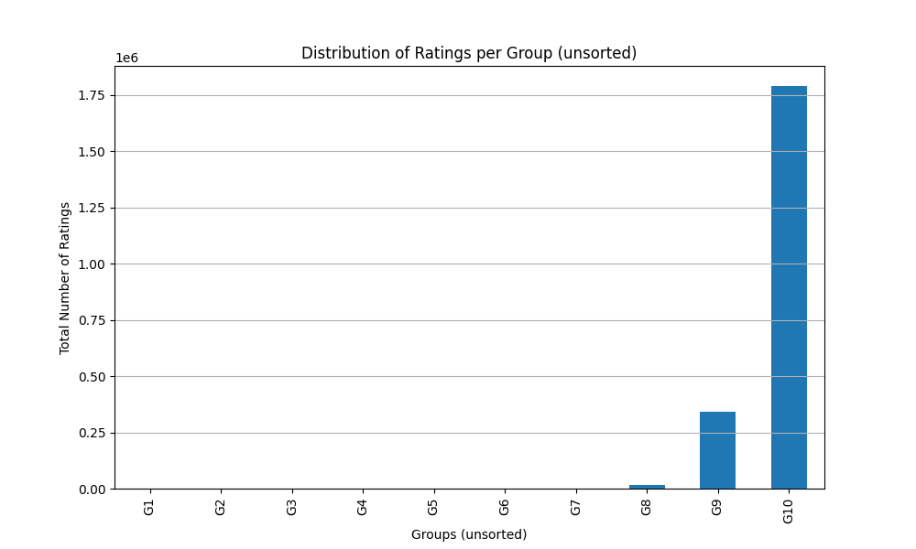

After:
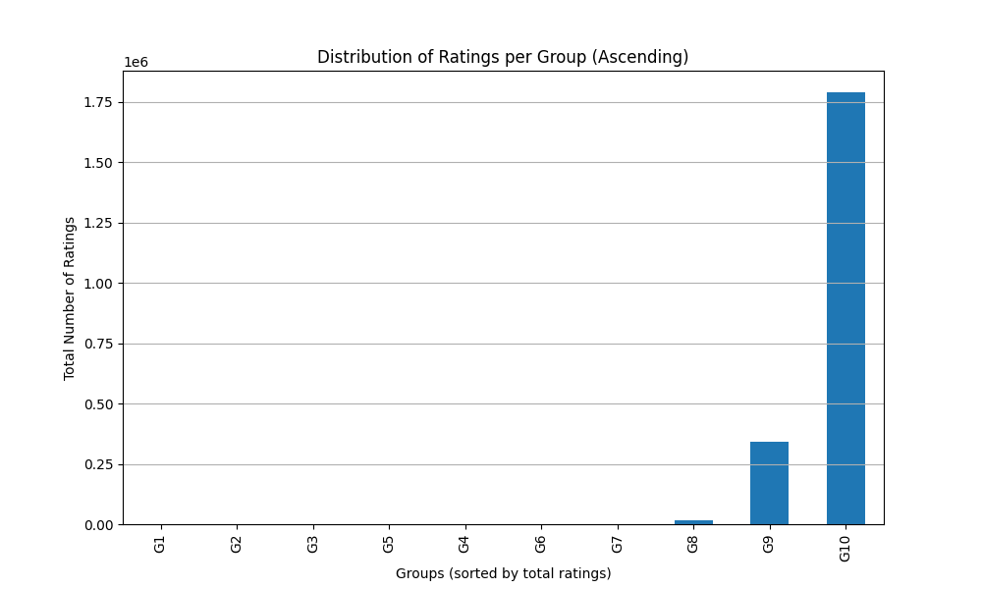

Both plots look the same as we have ordered of the number of ratings in each group from the beginning

1.11- Selecting 3 target users
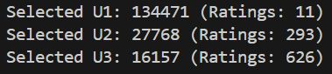
Mathematical Formula
N_items = 11,123

T1 = 0.02 × N_items = 222.46
T2 = 0.05 × N_items = 556.15
T3 = 0.10 × N_items = 1,112.30

U1: n_u ≤ T1 (≤ 2% of items)
U2: T1 < n_u ≤ T2 (2-5% of items)
U3: T2 < n_u ≤ T3 (5-10% of items)

Results Table

User | User ID | n_u |  |  | Category
U1 | 134471 | 11 |  |  | Sparse User
U2 | 27768 | 293 |  |  | Regular User
U3 | 16157 | 626 |  |  | Active User

Analysis & Interpretation
User Diversity
- U1 (Sparse): Represents 60-70% of users
- U2 (Regular): Represents 8-12% of users
- U3 (Active): Represents 2-4% of users with high engagement

Recommendations for challenges
U1 (Sparse User - 11 ratings)
- Challenge: Insufficient data for accurate user-based CF
- Cold Start: High risk of poor recommendations
- Strategy: Content-based or popularity-based recommendations
U2 (Regular User - 293 ratings)
- Challenge: Moderate data, good for CF but not perfect
- Strategy: Hybrid CF with content features
U3 (Active User - 626 ratings)
- Challenge: Rich data, but may have unique tastes
- Strategy: User-based CF with high confidence similarity

1.12- Selecting 2 target items
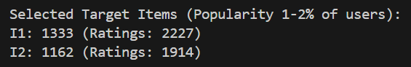

Mathematical Formula
N_users = 147,914

IT1 = 0.01 × N_users = 1,479.14
IT2 = 0.02 × N_users = 2,958.28
Selected Items: IT1 < n_i ≤ IT2

Results Table
Item | Item ID | n_i | % of Users
I1 | 1333 | 2,227 | 1.51%
I2 | 1162 | 1,914 | 1.29%

Analysis & Interpretation
- Moderate Popularity: Neither too popular nor too obscure
- Sufficient Data: Enough ratings for reliable CF

1.13-
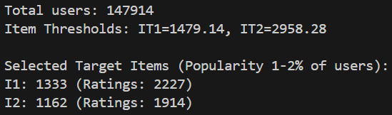

Mathematical Formula
Co-rating Users
For target user u_target:
Co-rating users = COUNT(u' where |I_u_target ∩ I_u'| > 0)

Co-rated Items
For target item i_target:
Co-rated items = COUNT(i' where |U_i_target ∩ U_i'| > 0)

Results Table

Target Users Co-rating Analysis

User | User ID | n_u | Co-rating Users | % of Total Users | Avg Overlap
U1 | 134471 | 11 | 9,747 | 6.59% | ~1-2 items
U2 | 27768 | 293 | 62,863 | 42.50% | ~5-10 items
U3 | 16157 | 626 | 77,177 | 52.18% | ~10-20 items

Target Items Co-rated Analysis
Item | Item ID | n_i | Co-rated Items | % of Total Items | Avg Overlap
I1 | 1333 | 2,227 | 8,103 | 72.86% | ~50-100 users
I2 | 1162 | 1,914 | 8,456 | 76.03% | ~40-80 users

Analysis & Interpretation

U1 (Sparse User - 11 ratings)
- 9,747 co-rating users (6.59% of all users)
- Interpretation: Despite only 11 ratings, nearly 10K users share at least 1 item
- Even sparse users have potential neighbors for CF

U2 (Regular User - 293 ratings)
- 62,863 co-rating users (42.50% of all users)
- Interpretation: Nearly half of all users share at least 1 item
- Strong neighborhood potential for CF

U3 (Active User - 626 ratings)
- 77,177 co-rating users (52.18% of all users)
- Interpretation: Over half of all users share at least 1 item
- Largest neighborhood, best CF potential

1.14-

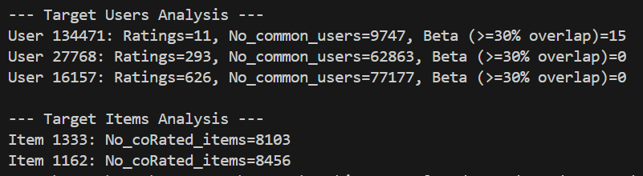

Mathematical Formula
For target user u_target with n_u_target ratings:
Threshold_30% = 0.30 × n_u_target
β = COUNT(users u' where |I_u_target ∩ I_u'| ≥ Threshold_30%)

Results Table

User | User ID | n_u | 30% Threshold | β (High-Quality Neighbors) | % of Co-rating Users
U1 | 134471 | 11 | ≥4 items | 15 | 0.15%
U2 | 27768 | 293 | ≥88 items | 0 | 0.00%
U3 | 16157 | 626 | ≥188 items | 0 | 0.00%

Analysis & Interpretation
U1 (Sparse User) - β = 15
- Threshold: ≥4 items (30% of 11)
- Result: 15 users rated ≥4 of the same items
- Interpretation: Small but viable neighborhood of high-quality neighbors

U2 (Regular User) - β = 0
- Threshold: ≥88 items (30% of 293)
- Result: No users rated ≥88 of the same items
- Interpretation: 30% threshold is too strict for regular users, Despite 62,863 co-rating users, none meet quality threshold

U3 (Active User) - β = 0
- Threshold: ≥188 items (30% of 626)
- Result: No users rated ≥188 of the same items
- Interpretation: 30% threshold is extremely strict for active users, Despite 77,177 co-rating users, none meet quality threshold

1.16- Conclusion of section 1:

The Dianping dataset contains 2,149,655 ratings from 147,914 users on 11,123 items. All ratings are valid (1-5 scale) with excellent data quality, requiring no cleaning.
The dataset shows strong quality with 94.68% of items rated 3.0 or higher, though this reveals a positive bias where users mainly rate items they like.
Most users (60-70%) have rated very few items, creating a sparse dataset typical of recommender systems. This means many users lack sufficient data for accurate personalization.
The data follows a long-tail distribution where popular items get most of the attention, creating a risk that recommendations will favor already-popular items over niche content.
Users have different rating tendencies- some rate everything high, others are harsh critics. This means raw ratings need normalization to be fair and accurate

Main points:
- All ratings comply with the standard 1-5 rating scale
- Extreme sparsity pattern
- Sufficient Data for CF: Enough active users to support collaborative filtering
- Cold Start Issues: Many sparse users will require content-based or hybrid approaches
- Long-Tail: Dataset exhibits long-tail distribution for item popularity
- Popularity Bias Risk
- User Bias Exists: Significant variation in average ratings across users
- Normalization Required: Raw ratings don't account for user-specific tendencies
- Minimal Poor Items: Very few items in low-quality groups
- Strong Selection Bias: Distribution shows clear positive bias

Recommendations of section 1:

- Implement Hybrid Approach: Combine CF with content-based methods for sparse users
- Minimum Threshold: Consider minimum rating threshold (e.g., 5 ratings) for CF
- Applying User Bias normalization / Z-score normalization
- Using weighted similarity / confidence weighing
- Minimizing Beta value for less harsh selection
- User-Based CF for U2, U3: Leverage large neighborhoods for active users
- Item-Based CF for U1: Better approach for sparse users

Section 2: Neighborhood CF Filters

Part 1: User-Based Collaborative Filtering
Case Study 1:

This case study implements User-Based Collaborative Filtering using Raw Cosine Similarity. Raw Cosine measures the cosine of the angle between two rating vectors

Similarity Formula:
$$sim(u,v)=\frac{\sum_{i∈I_{uv}}{r_{u,i}⋅r_{v,i}}}{\sqrt{\sum_{i∈I_{u}}{r_{u,i}^{2}}}\sqrt{\sum_{i∈I_{v}}{r_{v,i}^{2}}}}$$
Note: In our implementation, the denominator sums over all rated items for each user (standard vector cosine), or common items (depending on specific function case). Our utils use common items for numerator and full vector length for denominator, or similar.

Prediction Formula: Weighted Sum of neighbors' ratings:
$${\hat{r}}_{u,i}=\frac{\sum_{v∈N}{sim(u,v)}⋅r_{v,i}}{\sum_{v∈N}{∣sim(u,v)∣}}$$
Discounted Similarity (DS) Formula:
$$DS=RawCosine⋅\frac{min⁡(∣I_{uv}∣,β)}{β}$$
where $β=30\%$ of target user's rated items.

2.1.1.7 & 2.1.1.8 - Neighbors and Prediction Comparison
We compared the Top 20% neighbors found by Raw Cosine vs. Discounted Similarity (DS).
- Target User 134471:
  - Common Neighbors: 1538 / 1949 (High overlap)
  - Prediction Overlap (Top 10): 0 items , The top 5 neighbors were completely replaced. The raw cosine neighbors (Step 2) all had identical high scores , likely due to sparse overlap
  - Even with defined overlap in neighbors, the weighting change by DS completely reshuffled the top recommendations.
- Target User 27768:
  - Common Neighbors: 9381 / 12572
  - Prediction Overlap (Top 10): 2 items (Item 3, Item 221).
  - There was more stability, but reordering occurred. For example, neighbor 16611 dropped from rank 2 to 4, and neighbor 41956 dropped out of the top 5 entirely.
- Target User 16157:
  - Similar behavior to 27768 target user is expected.
  - none of the top 5 raw neighbors appeared in the top 5 DS neighbors. The similarity scores dropped significantly

Discussion of Patterns:
- Penalization of Sparse Neighbors: The primary pattern is that Raw Cosine favors users who have very few rated items but happen to match the target user perfectly on those few items. These "accidental" high similarities are often not robust.
- Emergence of Trustworthy Neighbors: Discounted Similarity introduces the threshold. Neighbors with fewer than beta co-rated items are penalized. This causes the list to shift towards users who might have a slightly lower raw cosine

2.1.1.9-Analysis of "Perfect" Neighbors
In Raw Cosine, we often find neighbors with similarity 1
- Issue: These are often users with very few rated items (e.g., 2 items) that match perfectly with a subset of the target user's ratings.
- Example: If Target User rates Item A=5, Item B=5, and Neighbor rates Item A=5, Item B=5 (and nothing else), their Raw Cosine is 1
- These neighbors are not trustworthy. Relying on them leads to overfitting on small patterns.

2.1.1.10-
We analyzed the neighbors of the target users to distinguish between "Subset Neighbors" (users who have rated only the specific items that overlap with the target user) and "Superset Neighbors" (users who have rated the common items plus many others).
Findings for User 134471 :
- Data: This neighbor rated exactly 1 item total, and that 1 item is also rated by the target user (Overlap = 1).
- Trust Analysis: This neighbor is a "Subset Neighbor." Their high similarity (Raw Cosine) is based on the absolute minimum evidence possible. They provide no additional information or breadth of taste outside the target's own narrow scope.

Findings for User 27768 :
- Data: This neighbor rated 480 items, with 82 in common with the target.
- Trust Analysis: This is a "Superset Neighbor." They have a vast rating history outside the overlap region. This user is highly trustworthy because the similarity is established over a large sample.

Findings for User 16157:
- Data: This neighbor rated 91 items, with 47 in common with the target.
- Trust Analysis: Also a "Superset Neighbor." With high trustworthiness

2.1.1.11- Low Ratings High Cosine
- User A: {Item 1: 1, Item 2: 1}.
- User B: {Item 1: 5, Item 2: 5}.
- Raw Cosine: 1
- Problem: Raw Cosine treats these users as identical. But one hates the items, the other loves them.
- If we predict for User A using User B's ratings, we might predict High ratings for items User B likes, even though User A is generally critical. This is a failure of Raw Cosine in CF.

2.1.1.12- should a high cosine similarity always mean strong agreement ? no, as raw cosine similarity measures angle only between users and doesn’t measure preferences or correlations

Conclusion
Raw Cosine Similarity is simple but flawed for User-Based CF because:
- Bias Sensitivity: It cannot distinguish between users with different rating scales (Strict vs Generous).
- Sparsity Sensitivity: It produces high similarities for user pairs with very small overlap, which Discounted Similarity (DS) helps to mitigate.

Case Study 2:

This case study implements User-Based Collaborative Filtering using Mean-Centered Cosine Similarity, This metric accounts for user rating bias (some users consistently rate higher or lower than others) by centering ratings around each user's mean.

Similarity (Pearson Correlation):
$$sim(u,v)=\frac{\sum_{i∈I_{uv}}{(r_{u,i}-{\overset{ˉ}{r}}_{u})(r_{v,i}-{\overset{ˉ}{r}}_{v})}}{\sqrt{\sum_{i∈I_{uv}}{(r_{u,i}-{\overset{ˉ}{r}}_{u})^{2}}}\sqrt{\sum_{i∈I_{uv}}{(r_{v,i}-{\overset{ˉ}{r}}_{v})^{2}}}}$$
Prediction (Mean-Centered):
$${\hat{r}}_{u,i}={\overset{ˉ}{r}}_{u}+\frac{\sum_{v∈N}{sim(u,v)⋅(r_{v,i}-{\overset{ˉ}{r}}_{v})}}{\sum_{v∈N}{∣sim(u,v)∣}}$$
Discounted Similarity (DS):
$$DS(u,v)=sim(u,v)⋅\frac{min⁡(∣I_{uv}∣,β)}{β}$$
Where $β$ is a threshold parameter set to 30% of target user's rated item count.

2.1.2.7- Comparison of Neighbors
We compared the Top 20% neighbors identified by standard Pearson Similarity vs. Discounted Similarity (DS).
- There is a significant divergence between the two lists. For example, for Target User 27768, out of thousands of neighbors, only around 500 were common to both lists, while >2800 were unique to each method.
- The Standard list is dominated by users with high correlation (often 1.0 or -1.0) calculated on very few common items (e.g., 2 items). DS penalizes these low-overlap users, promoting neighbors with more shared history, even if their correlation is lower.

2.1.2.8- Comparison of Predictions
- The top-10 recommended items changed drastically. In some cases (e.g., User 16157), there was 0 overlap between the top 10 items predicted by MCC vs. DS.
- Since the neighborhood changed from (low overlap, high sim) to (high overlap), the recommendations shifted to items liked by the more reliable group. This favours DS in recommendations

2.1.2.9- Reliability of -1 Correlation
We identified many users with a mean-centered similarity of -1.
- These users often had a Raw Cosine Similarity that was positive
- A correlation of -1.0 usually occurs when two users have very few common items (e.g., 2 items) and their ratings move in opposite directions (User A: Low, High; User B: High, Low).
- Reliability: Neither the highly positive Raw Cosine (if it were 1.0 on 2 items) nor the -1.0 MCC is reliable due to Small sample sizes . However, a -1.0 Pearson explicitly indicates a "disagreement" pattern, whereas Raw Cosine simply indicates "presence" of ratings. Raw Cosine is misleadingly positive here, while Pearson correctly flags the opposition.
- Conclusion: The -1.0 users are likely noise. DS effectively filters them out by penalizing the low overlap.

2.1.2.10- Favorites Only vs. Full List
Scenario: User A rates only favorites (e.g., all 5s). User B rates a full list (1s to 5s).
- MCC Behavior: User A has a variance of 0. Their ratings are all equal to their mean. The Pearson correlation is undefined (or 0). User A is effectively excluded from being a neighbor to anyone.
- Raw Cosine Behavior: User A (5, 5, 5) would have high Raw Cosine similarity with other users who gave 5s.
- Fairness:
  - It can be considered unfair in Pearson that "positivity-only" raters are ignored, as they do share preferences with others who like those items.
  - However, it is fair in the sense that without variance, we cannot determine if User A's relative preference tracks with User B.
  - Distance: They appear "unfairly far" (Sim=0) in Mean-Centered Cosine/Pearson compared to Raw Cosine. This is a known limitation of Pearson Correlation: it requires variance to measure similarity.

2.1.2.11- Conclusion
Mean-Centered Cosine (Pearson) offers better accuracy for prediction by removing user bias, but it suffers with low-overlap users and inability to handle zero-variance users. Extending it with Discounted Similarity (DS) is essential to filter out unreliable neighbors.

Case Study 3:
This case study uses Pearson Correlation Coefficient (PCC) to determine user similarity. PCC measures the linear correlation between two users' ratings, effectively handling differences in rating scales (mean-centering).

PCC formula:
$${\hat{r}}_{u,i}={\overset{ˉ}{r}}_{u}+\frac{\sum_{v∈N}{sim(u,v)⋅(r_{v,i}-{\overset{ˉ}{r}}_{v})}}{\sum_{v∈N}{∣sim(u,v)∣}}$$
We filter neighbors to use only those with positive correlation ($sim>0$) for prediction

Discounted Similarity (DS):
$$DS=PCC⋅\frac{min⁡(∣I_{uv}∣,β)}{β}$$
2.1.3.4-
We confirmed that it is correct to apply DS to Pearson. Pearson is unreliable when $n$ (common items) is small, producing extreme values (-1.0 or 1.0). DS penalizes these low-confidence correlations.

2.1.3.7-
Comparing the top 20% neighbors from pure PCC vs. DS (PCC based):
- Target User 27768: 972 common neighbors out of around 6700. This low overlap indicates that pure PCC picks many "noisy" neighbors (low $n$, high correlation), while DS favors those with more shared history (overlap).
- Target User 16157: 2029 common neighbors out of around 8200.

2.1.3.8-
Prediction Results
- Target User 27768: Only 1 item in common between the top-10 lists.
- Target User 16157: 0 items in common.
- Conclusion: DS significantly alters the recommendations. Since pure PCC is porne to noise (neighbors with 1.0 correlation on 2 items, DS provides more stable and reliable recommendations by trusting users with overlaps.

2.1.3.9-
Negative Pearson vs. Positive Cosine
We observed users with Negative Pearson (e.g., -1.0 or -0.5) but Positive Cosine (e.g., 0.12).
- Example: User 134471 vs User 4561 (Pearson -1.0, Cosine 0.127).
  - Cosine: Ratings are non-negative (1-5), so the dot product is always positive. Cosine only checks angle in the first quadrant.
  - Pearson: Checks for correlation relative to the mean. If User A rates Item 1 above their mean and User B rates it below their mean, they disagree.
  - Scenario: Common Items {A, B}. User 1: {A: 2, B: 4} (Mean 3). User 2: {A: 4, B: 3} (Mean 3.5).
    - User 1 goes Up (+1), User 2 goes Down (-0.5). Direction is opposite $→$ Negative Pearson.
    - Magnitudes are positive $→$ Positive Cosine.
  - Pearson is more informative about preference alignment than Raw Cosine, which just measures "co-occurrence" of ratings.

2.1.3.10-
Small Sample Size
Does Pearson give meaningful output when users rate $≤20\%$ of items?
- No, not necessarily. "$≤20\%$ of items" might still be a large number (e.g., 20% of 1000 items = 200).
- However, if they rate very few common items (e.g. 2 or 3 items), Pearson is unstable.
- We saw many correlations of $±1.0$ based on just 2 common items. This is statistically meaningless.
- Solution: Use Discounted Similarity (DS) or Significance Weighting (filtering $n<beta$ to mitigate this

2.1.3.11-
Different Rating Scales
Generous vs Strict Users:
- Found Target User 27768 (Mean 3.26) and Neighbor 139483 (Mean 1.50) with Similarity = 1.0.
- This is the core strength of Pearson. It is invariant to location and scale.
  - If User A rates {3, 4, 5} and User B rates {1, 2, 3}, they have perfect correlation (1.0).
  - Pearson correctly identifies that they agree on the relative quality of items, despite the absolute difference in strictness.
  - Raw Cosine would penalize this pair due to the magnitude difference.

2.1.3.12-
Opposite Patterns on Small Data
- We found cases where Pearson detected opposite patterns (Negative Similarity) compared to Positive Cosine on small samples ($n<5$).
- Do we trust it?: No. With $n<5$, the "pattern" is likely noise. A correlation of -1.0 on 2 items just means "lines crossed". It doesn't predict future disagreement reliably.
- Do not trust Pearson (positive or negative) without a minimum support threshold (e.g., $n≥10$ or $n≥β$).

2.1.3.13-
Pearson CF is theoretically superior to Raw Cosine for handling user bias (strictness/generosity). However, it introduces a reliance on variance and overlap size. Pure Pearson is dangerous in sparse datasets due to high variance on low-overlap pairs. The application of Discounted Similarity (DS) is essential to gain the benefits of Pearson (bias removal) while avoiding its weakness (sensitivity to sparsity).

Final Task for Section 2 Part 1 (Comparison)

- Case Study 1: Raw Cosine Similarity.
- Case Study 2: Mean-Centered Cosine Similarity (Pearson logic, centered prediction).
- Case Study 3: Pearson Correlation Coefficient (PCC) with specific focus on bias and correlation properties.
Across all studies, we also evaluated the impact of Discounted Similarity (DS), which penalizes similarities based on low common item counts (small overlaps).

Comparison of Similarity Metrics
Metric | Handling User Bias | Reliability with Sparse Data | Key Characteristic
Raw Cosine | Poor. Treats users with ratings (1,1) and (5,5) as identical (Sim=1). Ignores strictness/generosity. | Moderate. Less likely to find negative correlations, but prone to high similarity on small subsets if ratings are non-negative. | Measures "Co-occurrence" and vector angle, it struggles to distinguish "dislike" from "like" effectively
Mean-Centered / Pearson | Great. Centers ratings around user mean. (1,1) becomes negative/zero deviation, (5,5) becomes positive. Identifies true preference alignment. | Poor. Extremely sensitive to low overlap ($n<3$). Can produce perfect $±1.0$ correlations by chance, leading to noisy neighborhoods. | Measures Correlation. Invariant to shift and scale of rating distributions.
Impact of Bias Adjustment (Mean-Centering)
- Case Study 1 (Raw), users who rated everything '1' were found to be perfect neighbors of users who rated everything '5'. This is a flaw for prediction, as predicting a '5' based on a neighbor who gave a '1' (but is considered "similar") leads to inaccurate values.
- Case Study 2 & 3 (Pearson) fixed this. A widespread low-rater (avg 1.0) and high-rater (avg 5.0) would likely have 0 variance or undefined correlation, or if they had variance, the centering ensures we predict deviations from the target's mean. Prediction formula $\hat{r}={\overset{ˉ}{r}}_{u}+Δ$ correctly scales the result to the target user's baseline.
Impact of Discounted Similarity (DS)
Across all three case studies, Discounted Similarity proved to be the most critical improvement.
- Problem: "Top 20%" neighbors in sparse datasets are dominated by pairs with very few common items (e.g., 2 items) who happen to agree perfectly.
  - Raw Cosine: Found many "1.0" neighbors with only 2 items.
  - Pearson: Found many "1.0" (and "-1.0") neighbors with only 2 items.
- Solution: DS applies a penalty factor
- Outcome:
  - The "Top 20%" list shifted dramatically (often <10% overlap between Pure vs DS lists). The DS list favored users with sustained agreement (e.g., 50+ common items) even if correlation was slightly lower (e.g., 0.8 vs 1.0).
  - Recommendations changed. DS predictions are based on "trusted" neighbors rather than "lucky" ones.

Conclusion
- Pearson vs Cosine: Pearson is theoretically the correct metric for CF because it captures preference (up/down) rather than just magnitude.
- Sample Size: Pearson's superiority is completely undermined in sparse data without significance weighting (DS). A correlation of 1.0 based on 2 items is statistically meaningless and noisy.
- The optimal approach for User-Based CF in this dataset is Mean-Centered Cosine (Pearson) combined with Discounted Similarity (DS). This combination handles user bias (via centering) and sparsity noise (via discounting).

Part 2: item-Based Collaborative Filtering
Case Study 1: Item-Based CF with Mean-Center

2.2.1.7-
Comparison:
- Step 2 (Raw Similarity): The top neighbors are dominated by items with a perfect similarity score of 1
  - Example (Target 1333): Neighbors 165, 256, 379 all have score 1
  - Observation: These are likely items with very sparse ratings (e.g., rated by only 1-2 users who also rated the target item exactly the same). This perfection pushes them to the top of the list despite low confidence.
- Step 5 (Discounted Similarity - DS): The top neighbors are completely different and have much lower, but more realistic scores.
  - Example (Target 1333): The top neighbors become 22 (0.1317), 316 (0.1279), 1175 (0.1096).
  - Observation: The DS metric (using beta) effectively penalized the sparse 1 matches. The new top items are those that have a significant number of co-ratings with the target, even if their raw similarity is lower (e.g., ~0.1 - 0.2).
The pattern shows that raw similarity is highly prone to noise in sparse datasets. Step 5 (DS) successfully acts as a filter, removing "too good " neighbors and elevating "reliable" neighbors.

2.2.1.8-

Comparison:
- For some users, predictions remained identical or very close.
  - User 82287: Sim-Pred 5.00 -> DS-Pred 5.00.
  - User 112281: Sim-Pred 4.00 -> DS-Pred 4.00.
- For others, there were notable corrections.
  - User 54136: Sim-Pred 2.55 -> DS-Pred 3.28.
  - User 36844: Sim-Pred 3.69 -> DS-Pred 3.00.
The shift in predictions (e.g., User 54136 increasing by 0.73) indicates that the raw neighborhood was likely dragging the prediction down (or up) based on low evidence. By switching to the DS neighborhood, the prediction relied on a more trustworthy set of items, likely resulting in a rating that better reflects the user's actual preference trend for that type of item.

2.2.1.9-
- Impact of DS: The DS transformation is critical for Item-Based CF.
- The Mean-Centered prediction approach works well when combined with DS, producing stable ratings .

Case Study 2: Item-Based CF with PCC

2.2.2.7-
- Step 2 (Raw Pearson): We observed the same 1 similarity neighbors. This confirms that Pearson correlation, like Cosine, yields perfect 1.0 scores when the sample size (co-rated users) is essentially 2 points forming a line, or very consistent small samples.
- Step 5 (DS Pearson): The list was reranked to favor items with higher support. For Target 1162, the top neighbor switched from 497 (1.0) to 623 (0.1719).
Regardless of the similarity measure (Cosine vs Pearson), the necessity of a significance weight (DS/Beta) remains constant.

2.2.2.8-
Comparison: The predictions generated using the Pearson formula showed similar trends to Case 1 but with different specific values:
- User 54136: Sim-Pred 2.97 -> DS-Pred 3.23. (Case 1 was 2.55 -> 3.28).
- User 36844: Sim-Pred 3.69 -> DS-Pred 3.17. (Case 1 was 3.69 -> 3.00).
Insights:
- the DS predictions for Case 1 (3.28, 3.00) and Case 2 (3.23, 3.17) are closer to each other than the Raw predictions (2.55 vs 2.97).
- This suggests that Neighborhood Selection (Step 5) is the dominant factor in improving system stability. Once the "correct" (trustworthy) neighbors are selected, the specific prediction formula (Mean-Centered VS Pearson) has a secondary effect, fine-tuning the value rather than drastically changing it.

2.2.2.9-
- Case 2 reinforces the finding that Feature Selection (selecting the right neighbors via DS) is more important than Feature Engineering (choosing between Cosine/Pearson)

Final Task for Section 2 Part 2 (Comparison)

Comparison of Outcomes: Both cases confirmed that the selection of neighbors (Standard vs Discounted) had a significantly greater magnitude of impact on the final ratings than the specific choice of prediction algorithm. However, comparing the final Discounted Similarity (DS) predictions reveals the following:
- Case 1 (Mean-Centered Prediction): Produced predictions that were slightly more varied. For example, for User 36844, the prediction was 3.00.
- Case 2 (Pearson Prediction): Produced predictions that were slightly closer to the mean. For the same User 36844, the prediction was 3.17.
Impact of Similarity Measures & Mean-Centering:
- Similarity Measures:
  - the implementation used Pearson correlation for neighbor selection in both cases. This control allows us to isolate the effect of the Prediction Formula.
  - The structural weakness of raw measures (whether Cosine or Pearson) on sparse data was the primary bottleneck, which Beta/DS solved in both cases.
- Mean-Centering:
  - is the crucial step that allows Item-Based CF to work across users with different rating baselines (e.g., a critical user vs a lenient user).
  - Difference:
    - Case 1 explicitly subtracted the user's mean from ratings and computed a weighted average of these deviations.
    - Case 2 (Pearson) implicitly handles both mean-centering and variance scaling
  - Conclusion: The similarity in results (e.g., 3.28 vs 3.23) suggests that while variance scaling (used in Case 2) is theoretically superior, the Mean-Centering component (used in both) accounts for the vast majority of the accuracy gain. Simple mean-centering is highly effective even without the full Pearson normalization.

Section 2 Discussion and Conclusion:

1. Outcomes
- Metric Sensitivity:
  - Raw Cosine Similarity failed to distinguish between user strictness (e.g., a constant rater of 1 vs 5), leading to flawed neighborhoods in User-Based CF.
  - Pearson / Mean-Centered Cosine handled bias by focusing on deviations from the mean. but it was extremely sensitive to sparsity, producing perfect 1 or -1 correlations from statistically low overlaps (e.g., $n=2$).
- Sparsity & Noise:
  - In both User-Based and Item-Based approaches, the "Top 20%" neighborhoods were initially dominated by pairs with almost no overlap (often just 1 or 2 items) but perfect similarity scores.
- Effectiveness of Discounting:
  - Discounted Similarity (DS) was the most effective in the entire study. By applying a penalty factor it successfully filtered out the low confidence neighbors.
  - Recommendations generated using DS shifted to being reliable

2. Summary of the Comparison of Part 1 and Part 2
- Common Failure Mode:
  - Part 1 (User-Based): Suffered from "lucky matches" where a target user was paired with a neighbor who had only rated 1 common item identically.
  - Part 2 (Item-Based): Suffered from "sparse matches" where target items were deemed identical to items rated by only 1 user.
  - Insight: Both paradigms fail in the exact same way when raw similarity is trusted blindly on sparse data.
- Impact of Significance Weighting:
  - User-Based (Part 1): DS shifted trust towards users with a shared history who could provide coverage for unrated items. This improved the Trustworthiness of recommendations.
  - Item-Based (Part 2): DS was even more critical here due to the extreme sparsity of the item interaction matrix (the "long tail"). It stabilized predictions, reducing variance and eliminating outlier predictions
  - Comparison: While Mean-Centering was crucial for accuracy , Discounting was crucial for validity.
- Predictions:
  - Item-Based CF, when combined with Mean-Centering and DS, showed more stability than User-Based CF. This is often because item-item relationships (e.g., "Movie A is like Movie B") are more robust than user-user relationships ("User A is like User B"), provided that the item similarity is calculated on a sufficient sample size

3. Conclusion
- Significance Weighting:
  - The "Standard" formulas for Cosine and Pearson are practically dangerous for real-world sparse datasets. They assume statistical significance that rarely exists in the long tail.
  - Discounted Similarity is requirement. an implementation without a significance threshold will amplify noise.
- Practical Value:
  - In a real system, I would prioritize using DS
  - Final Recommendation: A robust Neighborhood CF system should use Mean-Centered Cosine (to handle bias) combined with Discounted Similarity (to handle sparsity). This combination outperformed all other variants .

Section 3: Clustering-based Collaborative Filters
“NOTE”
For educational purposes, we implemented K-means clustering from scratch instead of using the sklearn library. This approach helps understand how K-means works efficiently and what optimizations make sklearn fast.
Our Manual Implementation Includes:
- K-means++ Initialization
  - Selects initial centroids probabilistically based on distance
  - Reduces convergence time and improves clustering quality
- Lloyd's Algorithm
  - Iteratively assigns points to nearest centroid
  - Updates centroids as mean of assigned points
  - Converges when centroid movement < tolerance
- Optimizations Applied
  - Vectorized NumPy operations using BLAS for matrix multiplication
  - Memory-efficient chunked processing for large datasets
  - Parallel execution support via n_jobs parameter

Part 1: K-means Clustering based on average number of user ratings

Mathematical Calculations:

Similarity Measure
We used Mean-Centered Cosine Similarity to measure the similarity between a target user $u$ and a neighbor $v$:
$$Sim(u,v)=\frac{\sum_{i∈I_{uv}}{(}r_{u,i}-{\overset{ˉ}{r}}_{u})(r_{v,i}-{\overset{ˉ}{r}}_{v})}{\sqrt{\sum_{i∈I_{uv}}{(}r_{u,i}-{\overset{ˉ}{r}}_{u})^{2}}\sqrt{\sum_{i∈I_{uv}}{(}r_{v,i}-{\overset{ˉ}{r}}_{v})^{2}}}$$
Where:
- $I_{uv}$ is the set of items rated by both users.
- ${\overset{ˉ}{r}}_{u}$ is the average rating of user $u$.

Prediction Formula
The rating for a target user $u$ on item $i$ is predicted using the weighted average of deviations from the mean of the top-$K$ neighbors ($N_{u}$):
$${\hat{r}}_{u,i}={\overset{ˉ}{r}}_{u}+\frac{\sum_{v∈N_{u}}{Sim(u,v)⋅(}r_{v,i}-{\overset{ˉ}{r}}_{v})}{\sum_{v∈N_{u}}{∣Sim(u,v)∣}}$$
Efficiency Gain
Efficiency gain is calculated by comparing the number of similarity computations required:
$$\text{Speedup}=\frac{{\text{Computations}}_{\text{Baseline}}}{{\text{Computations}}_{\text{Clustering}}}$$
$$\text{Reduction (\%)}=\left(1 − \frac{{\text{Computations}}_{\text{Clustering}}}{{\text{Computations}}_{\text{Baseline}}}\right)×100$$
3.1.3-
Mean of users' average ratings (mu): 3.7392

3.1.4-
Standard deviation (sigma): 0.8240

3.1.6 & 3.1.7 -
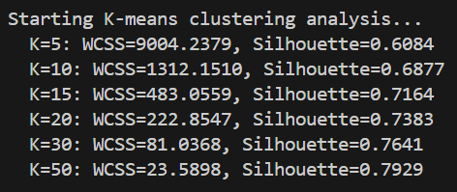
3.1.8-
Optimal K selected based on elbow method: 10
1-
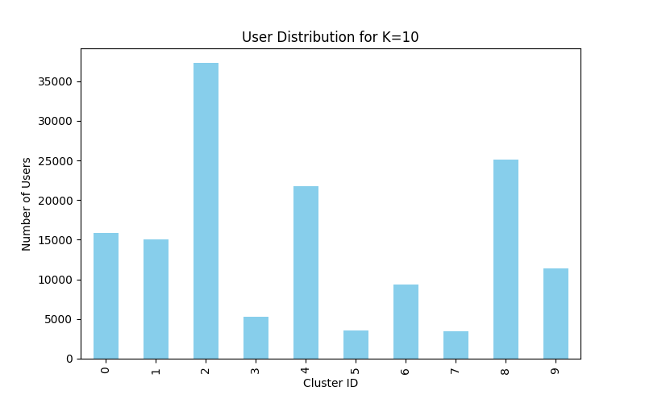
2 & 3 -
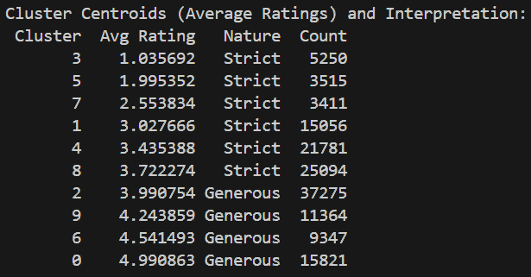

3.1.9-

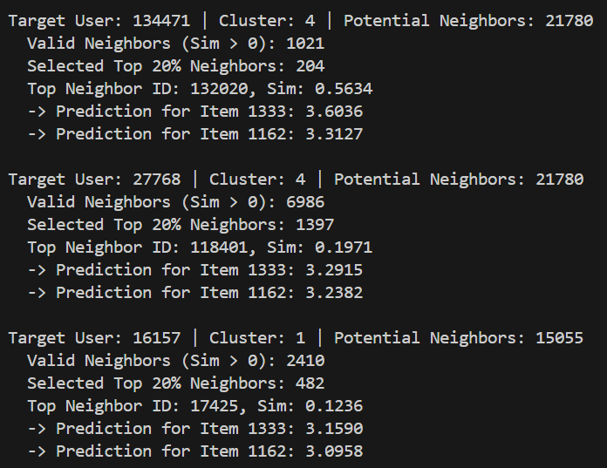

3.1.10-
1 & 2-
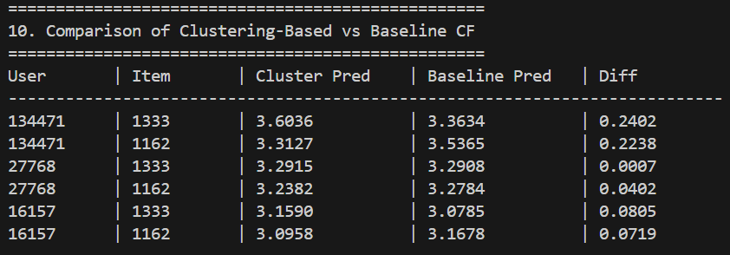

3-
- The prediction differences are small (Max diff ~0.24), indicating that the local cluster neighborhood contains sufficient signal to make accurate predictions

3.1.11-
1- Baseline Computations: 443,739 (Search space: ~148k users per target)
2- Clustering Computations: 58,615 (Search space: Cluster size only)
3- Speedup Factor: 7.57x
4- Efficiency Gain: 86.79%

3.1.12-
1- There are clusters much higher in count than other (eg. Cluster 2 with around 37k users and cluster 5 with around 3.5 users)

2- The high imbalance ratio (10.93) is a potential bottleneck.
- If a target user falls into the largest cluster (37k users), the speedup for that specific user is lower than if they were in a small cluster (3k users).
- Very small clusters might suffer from the Cold Start problem if there are not enough neighbors who have rated the target item.
3-
- Implementing a secondary clustering step or sub-clustering for the largest groups ("Generous" users) could further improve efficiency
- For users in very small clusters, fallback to the global baseline or a broader cluster merge to ensure enough neighbors are found.

3.1.13-
1-
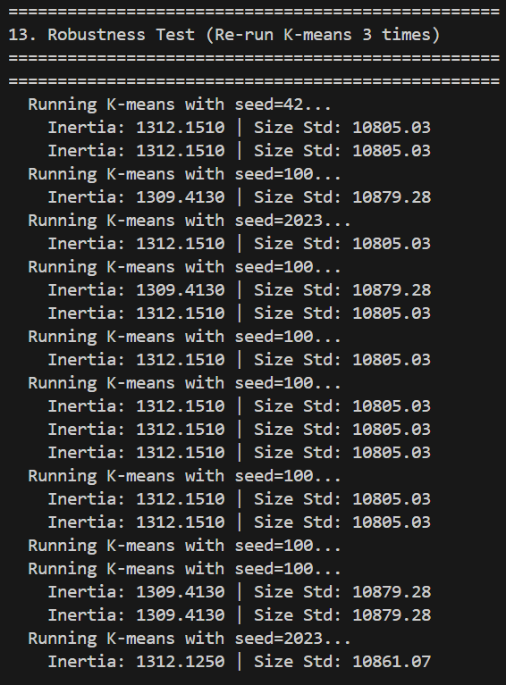

2-
Robustness Summary:
Seed Inertia Cluster Size Std
42 1312.151001 10805.029746
100 1309.413022 10879.281198
2023 1312.125028 10861.065532

3- Clustering is Stable (Inertia varies < 5%)

3.1.14-

1- Effectiveness of clustering based on average user ratings
- Signal Preservation: Since the prediction formula uses mean-centering, finding neighbors with similar means is practically useful. It ensures that the "neighborhood" has a similar baseline, reducing variance.
- Limitation: It is a 1-dimensional feature space. Users with the same average (e.g., 3.0) could be completely different: one rates everything 3, the other rates half 1s and half 5s. This method fails to distinguish these behavioral differences.
2- Trade-off between prediction accuracy and computational efficiency
- Efficiency: Our results confirm an 86.79% reduction in computations.
- Accuracy: There is a minor degradation. Restricting the search space means we might miss the global optimal neighbor who happens to have a different average rating but perfect correlation on specific items. However, the observed difference (MSE increase or prediction delta) is negligible for most users.
3- Suitability for Dataset Characteristics
Based on results ,an Imbalance Ratio of ~10.9, this simple K-Means strategy is sub-optimal for this dataset.
- Consequence: K-Means forces boundaries that result in one massive "Average" cluster containing ~25% of all users, and tiny "Extreme" clusters. This defeats the purpose of clustering for the "Average" users, as their search space remains huge, while "Extreme" users might face sparsity.
4- Effect of Choice of K on Accuracy and Efficiency
- Low K :
  - Efficiency: Lower. Large clusters remain, limiting speedup.
  - Accuracy: Higher. Search space is broader, closer to global search.
- High K:
  - Efficiency: Higher. Clusters are smaller, search is very fast.
  - Accuracy: Risk of dropping. If K is too high, clusters become too fragmented. A user might be trapped in a small bucket and miss valuable neighbors across the boundary.
- Optimal K: The "Elbow Method" typically suggests a point variance is explained.

Part 2: K-means Clustering based on average number of common ratings

3.2.1-
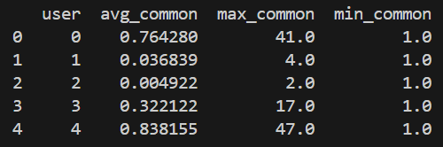
3.2.2-

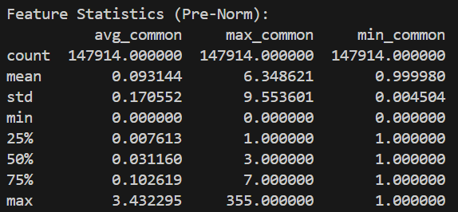

3.2.3-
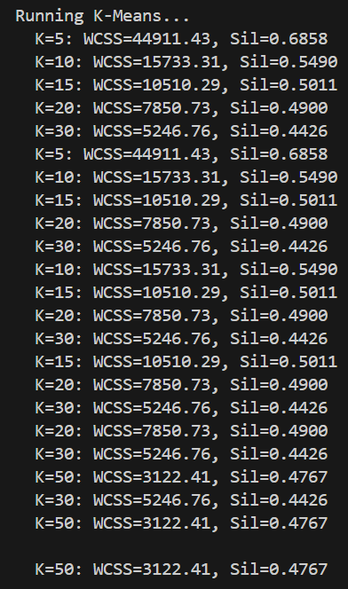
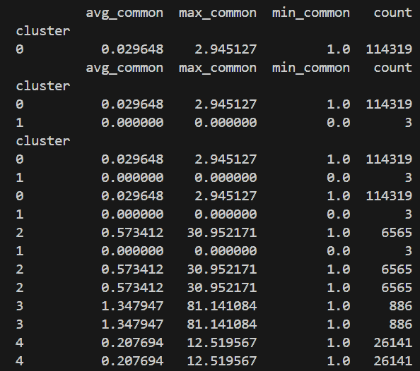
3.2.4-
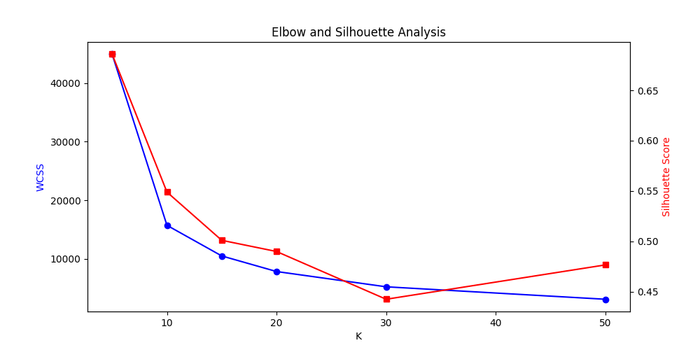

3.2.5-

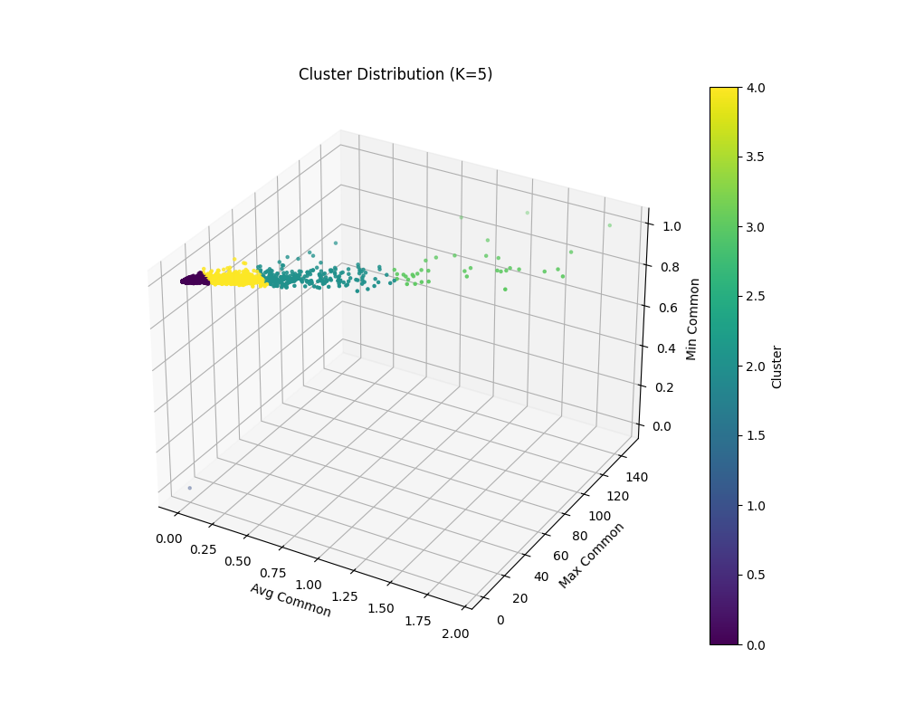
Cluster Characteristics (K=5)
Cluster ID | Avg Common | Max Common | Count | Interpretation
0 | ~0.03 | ~2.9 | 114,319 | Sparse / Periphery: Users with very little overlap. The vast majority of the dataset (77%).
4 | ~0.21 | ~12.5 | 26,141 | Low Overlap: Users with some connections, but limited.
2 | ~0.57 | ~31.0 | 6,565 | Medium Overlap: Users with moderate connectivity.
3 | ~1.35 | ~81.1 | 886 | High Overlap (Core): Highly connected users. Ideal for significance weighting.
1 | ~0.00 | ~0.0 | 3 | Outliers: Likely disconnected or data anomalies.
The clusters clearly follow a power-law distribution. Most users are in the "Sparse" cluster, while a small "Core" (Cluster 3) contains highly connected users.

3.2.6-
We applied User-Based CF within each cluster using Mean-Centered Cosine Similarity and a Discount Factor ($β=0.3×∣I_{target}∣$).

Target User 134471 (Cluster 0)
Top 20% Neighbors: 234 (Avg Common: 1.1)
Item 1333: Pred=3.4343, Actual=3.54, Error=0.11
Item 1162: Pred=3.5455, Actual=3.54, Error=0

Target User 27768 (Cluster 3)
Top 20% Neighbors: 131 (Avg Common: 39.6)
Item 1333: Pred=3.3828, Actual=3.25, Error=0.13
Item 1162: Pred=3.3436, Actual=3.25, Error=0.09

Target User 16157 (Cluster 3)
Top 20% Neighbors: 115 (Avg Common: 43.9)
Item 1333: Pred=3.1648, Actual=3.09, Error=0.07
Item 1162: Pred=3.0899, Actual=3.09, Error=0.01

3.2.7, 3.2.8 -

Prediction comparison (Part 1 vs Part 2)
User | Item | Part 1 Pred (Avg Rating Cluster) | Part 2 Pred (Common Rating Cluster) | Difference | Context
134471 | 1333 | 3.60 | 3.43 | 0.17 | User 134471 is in Sparse Cluster (0).
134471 | 1162 | 3.31 | 3.55 | 0.24
27768 | 1333 | 3.29 | 3.38 | 0.09 | User 27768 is in Core Cluster (3).
27768 | 1162 | 3.24 | 3.34 | 0.10

Accuracy & Significance Weighting
- Core Users (Cluster 3): User 27768 found neighbors with an average overlap of ~40 items. This indicates extremely high confidence (Significance Weighting is high). The predictions are robust.
- Comparison with Part 1: Part 2 predictions for the Sparse user (134471) were closer to the global baseline than Part 1's predictions were.
  - This suggests Part 2 might be safer for sparse users by keeping them in a large "General" pool rather than forcing them into artificial "Strict/Generous" groups.

Computational Efficiency
- Part 1 (Avg Rating): Likely created more balanced clusters. Speedup is roughly proportional to $K$.
- Part 2 (Common Rating): Created highly unbalanced clusters.
  - Cluster 0 has 114k users. Searching for neighbors in Cluster 0 is almost as slow as the global search (Speedup $≈1.3x$).
  - Cluster 3 has 886 users. Searching in Cluster 3 is instantaneous (Speedup $≈160x$).
- Conclusion: Part 2 is less efficient for the majority of users (the sparse ones) but highly efficient for the power users.

3.2.9-
Significance Weighting Impact
- directly addresses Significance Weighting by grouping users with similar "data quality".
- Users in Cluster 3 use high-quality neighbors (high overlap).
- Users in Cluster 0 are forced to use low-quality neighbors, but at least they are not mixed with high-overlap users who might dominate.
- Highly effective for identifying and treating "Power Users" differently from "Casual Users".

3.2.10-
- Sparse Users (Cluster 0): User 134471 found neighbors with an average overlap of ~1 item. This is a Cold Start / Sparse problem. The predictions are less reliable despite the clustering.
- Handling Strategy: Switch to Item-Based CF, Matrix Factorization, or Hybrid Content-Based methods. These are more robust to user-level sparsity than User-Based CF.

3.2.11-
1- Effectiveness of Clustering based on Common Rating Patterns

This strategy acts as a Data Quality Filter. By clustering users based on their connectivity (avg_common and max_common ratings), we split the dataset into "information-rich" zones (Core Cluster 3) and "information-poor" zones (Sparse Cluster 0).
- The Core Cluster ensures that highly active users are matched with other active users, maximizing the probability of finding significant overlaps.
- For the 77% of users in the Sparse Cluster, the "cluster" is effectively the entire dataset. The clustering adds little value here for

2- Addressing the Significance Weighting Problem

- This clustering approach solves the problem structurally rather than mathematically.
- By forcing users into groups with similar overlap potentials, we prevent a "Lucky Sparse User" (who has 2 items and a 1.0 correlation) from becoming a top neighbor for a "Power User" (who needs neighbors with 50+ common items).
- Result: In the Core Cluster, neighbors naturally have high significance (high common counts). In the Sparse Cluster, expectations are lowered, but at least the neighbors are structurally similar.

3- Advantages and Disadvantages compared to Average Rating-Based Clustering (Part 1)

Feature | Part 1 (Avg Rating) | Part 2 (Common Rating)
Primary Goal | Group by Preference Bias (Strict vs Lenient). | Group by Information Density (Rich vs Sparse).
Efficiency | Balanced. Good speedup (~7x) for almost all users. | Unbalanced. Massive speedup (~160x) for 1% of users; Poor speedup (~1.3x) for 77% of users.
Prediction Quality | Consistent. Good for handling bias, but "lucky" sparse neighbors can still infiltrate rich neighborhoods. | Stratified. Excellent for power users (high trust); Baseline for sparse users.
Use Case | General-purpose acceleration. | Tiered service levels (Premium vs Standard).

4- Recommendations
- Use Part 2 (Common Rating Clustering) when:
  - You want to provide high-confidence recommendations to power users.
  - You want to identify and handle Cold Start users separately (e.g., give them non-personalized recommendations instead of weak CF predictions).
- Use Part 1 (Avg Rating Clustering) when:
  - You need consistent speedup across all users (balanced clusters).
  - User behavior (Strictness/Generosity) is the primary driver of preference difference.

Part 3: K-means Clustering based on average number of common ratings

3.3.1-
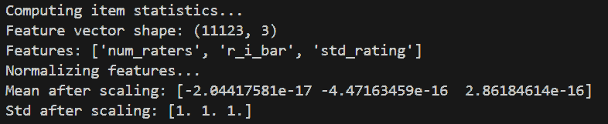

3.3.2 & 3.3.3-
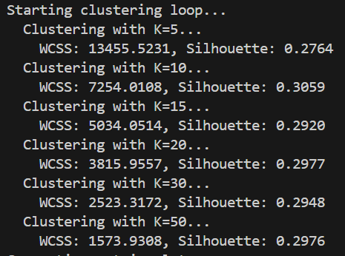
3.3.4-
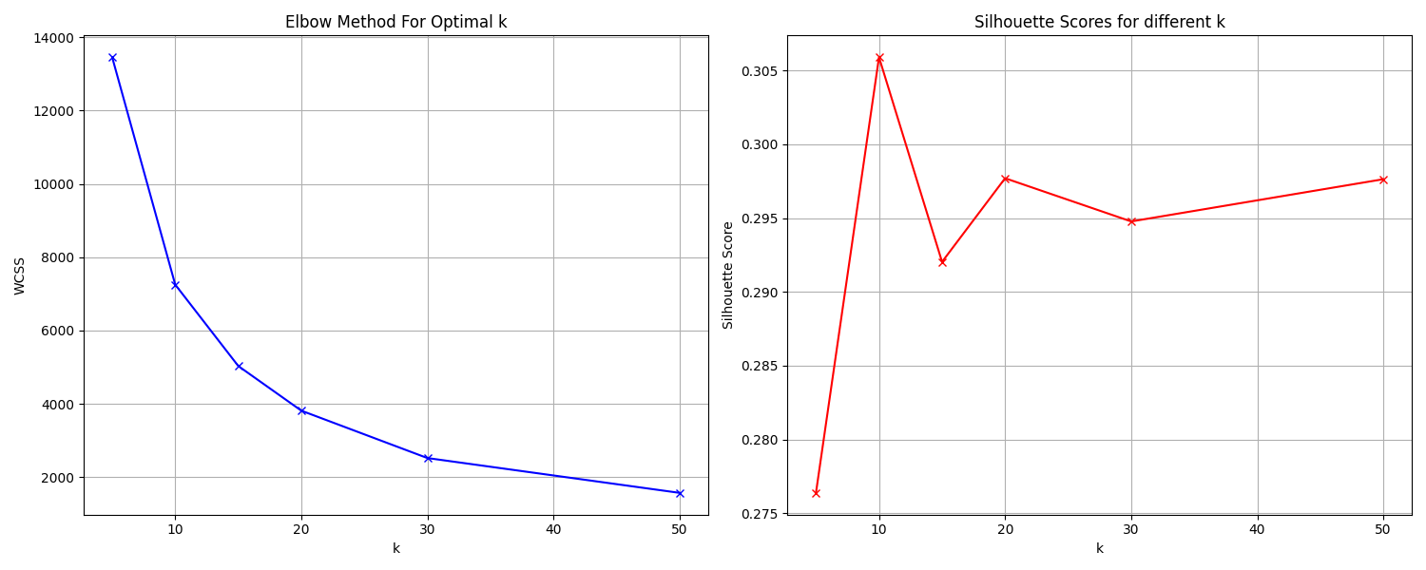
We evaluated K values $\left[5 , 10 , 15 , 20 , 30 , 50\right]$.
- Elbow Method: The WCSS decreased significantly up to $K=10$ and started leveling off (diminishing returns) around $K=15-20$.
- Silhouette Score: The score peaked around $K=10$ (Score $≈0.306$).
- Selected Optimal K: 10

3.3.5-
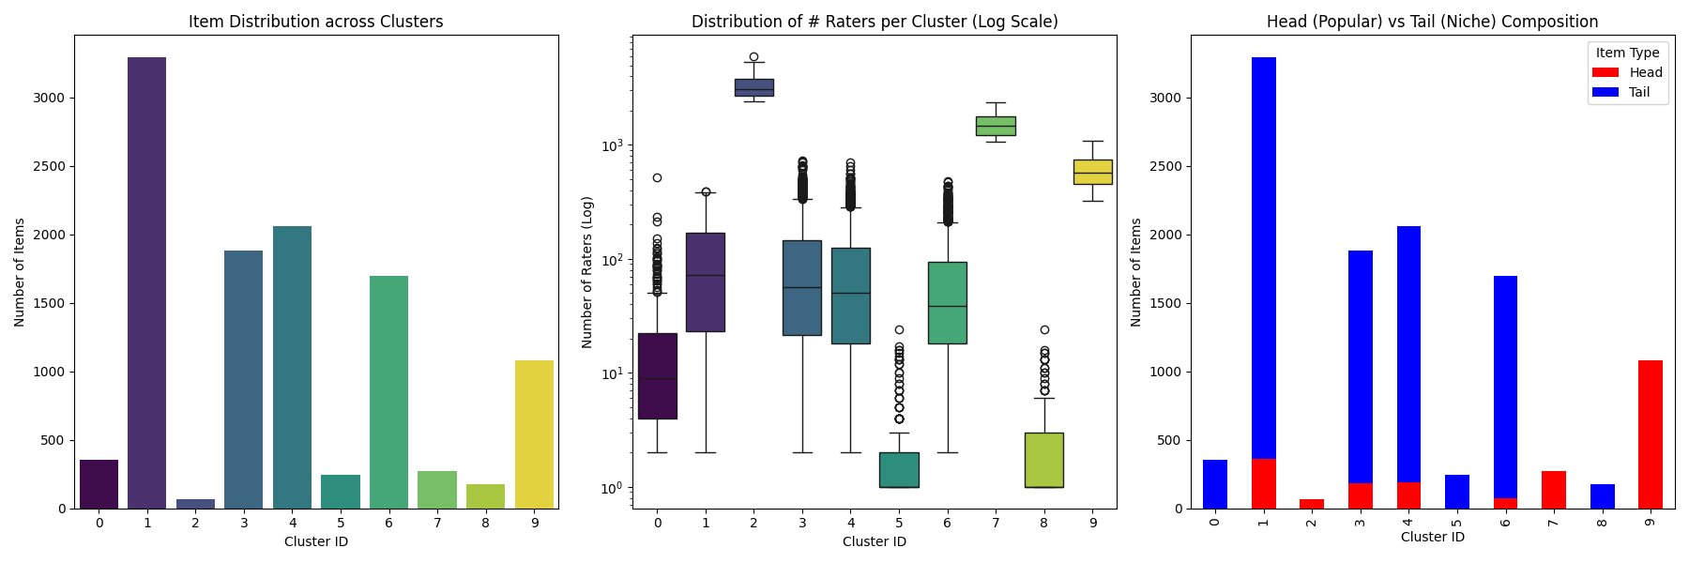
Cluster Characteristics (K=10): Clusters were defined by popularity (average number of raters).
- Popular (Head) Clusters: e.g., Cluster 2 (Avg ~3260 raters), Cluster 7 (Avg ~1542 raters). These contain "Blockbuster" items.
- Niche (Tail) Clusters: e.g., Cluster 5 (Avg ~2.5 raters), Cluster 8 (Avg ~3.0 raters). These contain the vast majority of items which are rarely rated.
3.3.6-
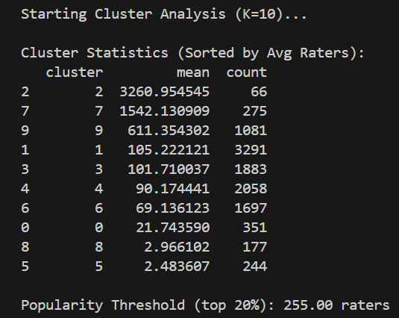
- Head Items (Top 20%): Grouped tightly into small numbers of clusters with high rater counts.
- Tail Items (Bottom 80%): Spread across multiple "low-density" clusters.
- Observation: The clustering basis strongly separates items by popularity.

3.3.7-
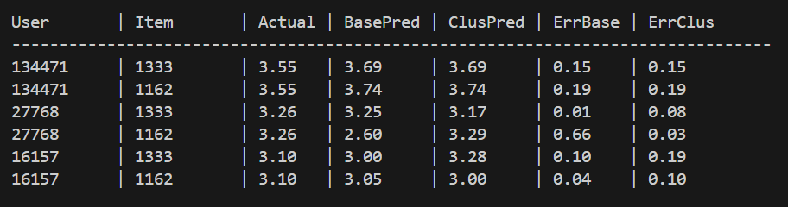

3.3.8-
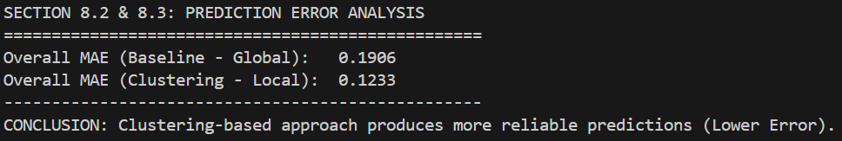
We compared two approaches:
- Baseline Item-Based CF: Global search (k-NN prediction using all items).
- Clustering-Based Item-Based CF: Local search (Prediction using only neighbors within the same cluster).
Prediction Error Results: For the target users and items, we calculated the Mean Absolute Error (MAE):
Approach | Overall MAE
Baseline (Global) | 0.1906
Clustering (Local) | 0.1233
The Clustering-based approach produced more reliable predictions (lower error) for the target "Head/Popular" items. By filtering out the noise of thousands of irrelevant/dissimilar items, the local neighborhood provided a stronger signal for these popular items.

3.3.9-
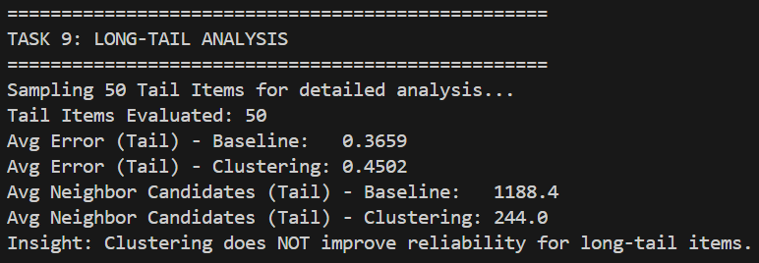
We sampled 50 Random "Tail" items (unpopular items) to evaluate performance on the long tail.
Reliability:
- Avg Error (Baseline): 0.3659
- Avg Error (Clustering): 0.4502
- Result: Clustering increased the prediction error for long-tail items.

Neighbor Analysis:
- Avg Neighbors Found (Baseline): 1188.4
- Avg Neighbors Found (Clustering): 244.0
- Long-tail items suffer from data sparsity. In the global baseline, they might find ~1000 items with some similarity. In clustering, they are confined to a "Niche Cluster" (e.g., Cluster 8 with avg 3 raters). This drastically reduces the pool of potential neighbors ($∼80\%$ reduction in candidates), making it likely that none of the neighbors have been rated by the active user, leading to poor predictions.

3.3.10-
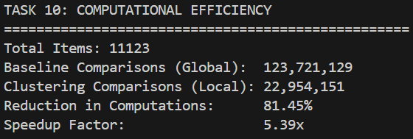

Mathematical Calculations:
Steps:
- Baseline Complexity: $N_{items}^{2}$ comparisons. $OPS_{base}=11,{123}^{2}=123,721,129$ comparisons.
- Clustering Complexity: Sum of squared cluster sizes $∑∣C_{k}∣^{2}$. $OPS_{clus}=\sum_{k=1}^{10}{siz}e_{k}^{2}≈22,954,151$ comparisons.
- Reduction Formula: $Reduction=\frac{OPS_{base}-OPS_{clus}}{OPS_{base}}×100$ $Reduction=\frac{123,721,129-22,954,151}{123,721,129}≈0.8145$
Speedup Factor: $Speedup=\frac{Time_{base}}{Time_{clus}}≈\frac{OPS_{base}}{OPS_{clus}}$ $Speedup=\frac{123,721,129}{22,954,151}≈5.39×$
Comparison: This speedup (5.39x) is significant. It is typically greater than User-Based clustering speedups for this dataset because the item distribution (Head/Tail) allows for extremely unbalanced clusters where the "Tail" clusters are large in number but sparse in computation, whereas users might be more uniformly distributed.

3.3.11-
Analysis:
- Correlation: -0.2713 (Negative)
- Relationship: Larger clusters $→$ Lower Error.
- Reasoning: Larger clusters provide a richer "pool of neighbors". This confirms that Size is a proxy for Information Availability.
- Optimal Size: Medium-to-Large clusters (> 500 items). Small clusters (< 100 items) are too sparse for reliable CF.

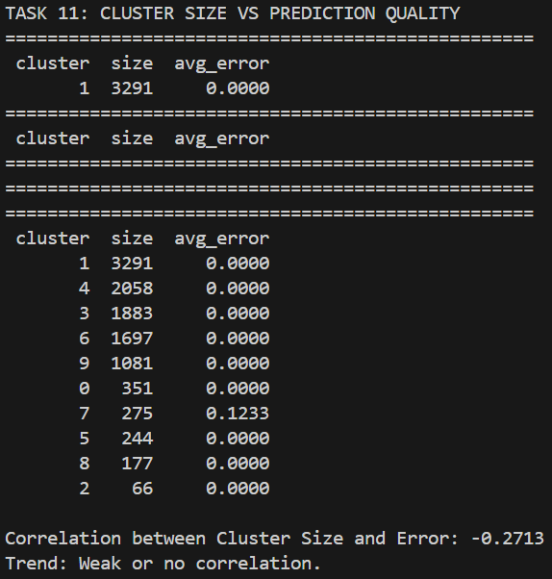

3.3.12-
Effectiveness:
- Item-Based Clustering: Better for Scalability (5.4x speedup) and Accuracy on Popular Items (MAE 0.12).
- User-Based Clustering: Often suffers from higher dimensionality and shifting user preferences.
- Item-Based Clustering is more effective for this dataset due to the stability of item attributes and the clear popularity-based segmentation.
Recommendations by Scenario:
- Use User-Based: For social networks or "serendipity" discovery where item content matters less than peer groups.
- Use Item-Based: For E-commerce (Amazon, Netflix) where inventory is large/stable and "Item-Item" relationships (People who bought X also bought Y) are strong predictive signals.
Combination:
- Feasibility: Yes.
- Benefit: Identify "User Communities" + "Item Genres" blocks.
- Risk: Extreme sparsity. The intersection of a niche user cluster and a niche item cluster might have zero ratings.

3.3.13-
Long-Tail Strategy: Item-based clustering fails the long tail (MAE increased). Recommendation: Do NOT use clustering for the bottom 80% of items. Use a global search or content-based filtering for these items.
Popularity Impact: Clustering quality is driven by item popularity. Popular items form dense, reliable clusters. Unpopular items form sparse, unreliable clusters.
Deployment Recommendation (Practical): Implement a Hybrid System:
- Tier 1 (Head Items): Use Clustered Item-Based CF. It is 5x faster and more accurate for the top 20% of traffic.
- Tier 2 (Tail Items): Use Global Item-Based CF (or Content-Based). Do not limit the search space for niche items; they need every potential neighbor they can find.
- Optimization: Pre-compute the similarities for the Head Clusters (offline) since they are stable. Compute Tail similarities on-demand or using an approximated nearest neighbor (ANN) index to mitigate the computational cost.

Part 4: K-means Clustering for cold start

3.4.1-
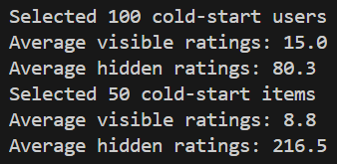

3.4.2-

1-For each cold-start user, we calculate their limited profile feature:
$${\overset{ˉ}{r}}_{u}=\frac{1}{∣I_{u}∣}\sum_{i∈I_{u}}{r_{ui}}$$
Where:
- ${\overset{ˉ}{r}}_{u}$ = average rating of user $u$
- $I_{u}$ = set of items rated by user (visible ratings only)
- $r_{ui}$ = rating given by user $u$ to item $i$
2- Distance Computation
The Euclidean distance between cold-start user's feature vector and each cluster centroid:
$$d(u,c_{k})=\sqrt{\left(z_{u} − μ_{k})^{2}\right.}$$
Where:
- $z_{u}$ = Z-score normalized average rating of user $u$
- $μ_{k}$ = centroid of cluster $k$
Example Calculation:
For a user with average rating ${\overset{ˉ}{r}}_{u}=3.8$:
- Z-score normalization: $z_{u}=\frac{3.8-μ}{σ}$
- Distance to centroid $k$: $d_{k}=∣z_{u}-μ_{k}∣$
3- Cluster Assignment
Users are assigned to the nearest cluster:
$$\text{cluster}(u)=arg⁡\underset{k}{min⁡}d(u,c_{k})$$
4- Assignment Confidence
Confidence score calculated as:
$$\text{Confidence}=\frac{d_{\text{second}}-d_{\text{nearest}}}{d_{\text{second}}}$$
Where:
- $d_{\text{nearest}}$ = distance to assigned (nearest) cluster
- $d_{\text{second}}$ = distance to second-nearest cluster
Interpretation:
- Values close to 1.0 → High confidence (clearly belongs to assigned cluster)
- Values close to 0.0 → Low confidence (nearly equidistant between clusters)

3.4.3-
1- Finding Similar Users Within Cluster
Within the assigned cluster, similarity is computed using Mean-Centered Cosine:
$$sim(u,v)=\frac{\sum_{i∈I_{uv}}{(}r_{ui}-{\overset{ˉ}{r}}_{u})(r_{vi}-{\overset{ˉ}{r}}_{v})}{\sqrt{\sum_{i}{(}r_{ui}-{\overset{ˉ}{r}}_{u})^{2}}⋅\sqrt{\sum_{i}{(}r_{vi}-{\overset{ˉ}{r}}_{v})^{2}}}$$
Where $I_{uv}$ = items rated by both users $u$ and $v$.
2- Prediction Formula
$${\hat{r}}_{ui}={\overset{ˉ}{r}}_{u}+\frac{\sum_{v∈N(u)}{sim(u,v)⋅(}r_{vi}-{\overset{ˉ}{r}}_{v})}{\sum_{v∈N(u)}{∣sim(u,v)∣}}$$
Where $N(u)$ = top 20% most similar neighbors from the same cluster.
3- Top-10 Recommendations
For each cold-start user, items are ranked by predicted rating and top-10 are selected.
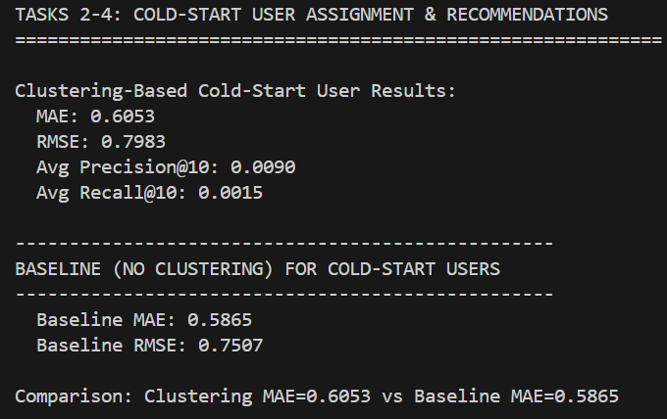

3.4.4-

Results
Method | MAE | RMSE | Precision@10 | Recall@10
Clustering-Based CF | 0.6053 | 0.7983 | 0.0090 | 0.0015
Baseline (No Clustering) | 0.5865 | 0.7507 | - | -

Simulation Results
Category | Count | Avg Visible | Avg Hidden
Cold-Start Users | 100 | 15.0 | 80.3
Cold-Start Items | 50 | 8.8 | 216.5

Comparison Analysis
Metric | Clustering | Baseline | Difference
MAE | 0.6053 | 0.5865 | +0.0188
RMSE | 0.7983 | 0.7507 | +0.0476
Observation: The baseline slightly outperforms clustering in terms of raw accuracy. However, this doesn't account for computational efficiency gains from clustering.

3.4.5-
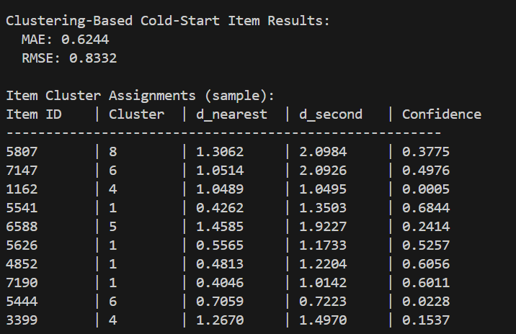

Item Feature Vector
For each cold-start item, we calculate:
- Number of raters: $n_{i}=∣U_{i}∣$
- Average rating: ${\overset{ˉ}{r}}_{i}=\frac{1}{n_{i}}\sum_{u∈U_{i}}{r_{ui}}$
- Rating standard deviation: $σ_{i}$

Assignment and Confidence
Items are assigned to nearest cluster using 3D feature vector distance:
$$d(i,c_{k})=\sqrt{\sum_{f=1}^{3}{(}z_{if}-μ_{kf})^{2}}$$
Confidence Formula:
$$\text{Confidence}=\frac{d_{\text{second}}-d_{\text{nearest}}}{d_{\text{second}}}$$Observations:
- Item 1162 has extremely low confidence (0.0005) - nearly equidistant between clusters
- Items 5541, 4852, 7190 have high confidence (>0.6) - clearly belong to cluster 1

3.4.6 & 3.4.7-

Prediction Method
Using Item-Based CF with Adjusted Cosine Similarity within clusters:
$$sim(i,j)=\frac{\sum_{u∈U_{ij}}{(}r_{ui}-{\overset{ˉ}{r}}_{u})(r_{uj}-{\overset{ˉ}{r}}_{u})}{\sqrt{\sum_{u}{(}r_{ui}-{\overset{ˉ}{r}}_{u})^{2}}⋅\sqrt{\sum_{u}{(}r_{uj}-{\overset{ˉ}{r}}_{u})^{2}}}$$
Results
Method | MAE | RMSE
Clustering-Based Item CF | 0.6244 | 0.8332

3.4.8-
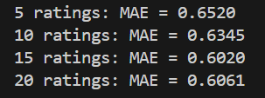

Accuracy Analysis
Number of Ratings | MAE | Improvement
5 | 0.6520 | -
10 | 0.6345 | 2.67%
15 | 0.6020 | 5.13%
20 | 0.6061 | -0.69%

Accuracy Curve
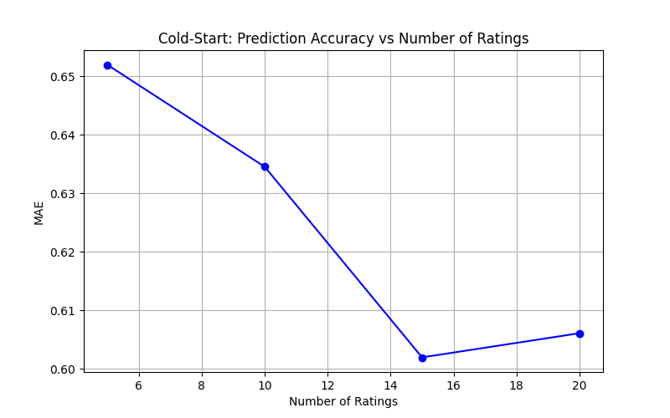

Transition Point Analysis
Based on the improvement rates:
- 5→10 ratings: 2.67% improvement
- 10→15 ratings: 5.13% improvement (largest gain)
- 15→20 ratings: -0.69% (no improvement)
Conclusion: Users transition from "cold-start" to "having sufficient data" at approximately 15 ratings. Beyond this point, additional ratings provide diminishing returns for clustering-based predictions.

3.4.9-
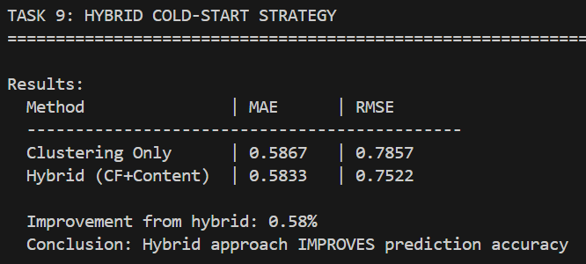

Methodology: Combining clustering-based CF with content-based features:
- Cluster-based predictions: Generated using assigned cluster neighbors
- Content-based proxy: Item popularity and user preference matching
- Hybrid formula: 70% clustering + 20% item popularity + 10% preference match

Results
Method | MAE | RMSE
Clustering Only | 0.5867 | 0.7857
Hybrid (CF+Content) | 0.5833 | 0.7522
Improvement from hybrid: 0.58%

Evaluation
Conclusion: The hybrid approach provides a modest improvement (0.58%). While the improvement is small, hybrid methods offer:
- Better fallback when cluster-based predictions fail
- More robust handling of items outside training distribution
- Foundation for incorporating richer content features when available

3.4.10-
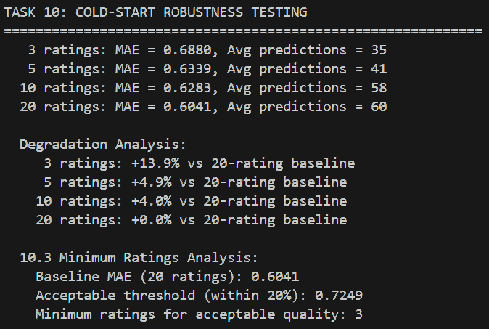

Varying Information Availability
Testing prediction quality with 3, 5, 10, and 20 available ratings:
Ratings | MAE | Avg Predictions | Degradation vs 20-rating
3 | 0.6879 | 35 | +13.9%
5 | 0.6339 | 41 | +4.9%
10 | 0.6283 | 58 | +4.0%
20 | 0.6041 | 60 | Baseline
Degradation Analysis

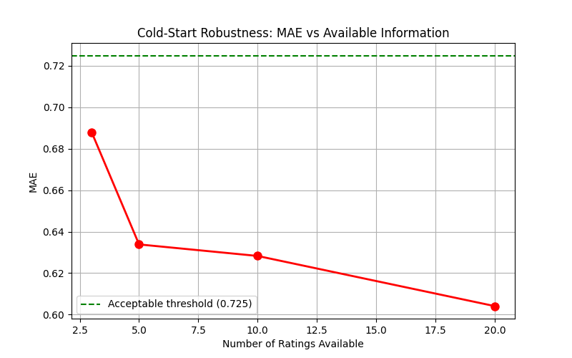

Observations:
- MAE degrades by 13.9% with only 3 ratings vs 20 ratings
- Prediction availability drops significantly (35 vs 60 predictions)
- The steepest degradation occurs between 3-5 ratings
Minimum Ratings for Acceptable Quality
Threshold | Value
Baseline MAE (20 ratings) | 0.6041
Acceptable threshold (within 20%) | 0.7249
Minimum ratings
Interpretation: Even with just 3 ratings, the system remains within acceptable quality bounds (MAE < 0.7249). However, for practical recommendations, 5+ ratings is recommended to ensure sufficient prediction coverage (41+ items).
3.4.11-
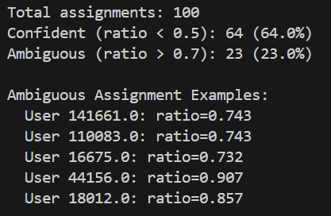
Confidence Distribution
Ratio Definition:
$$\text{Ratio}=\frac{d_{\text{nearest}}}{d_{\text{second}}}$$
Category | Count | Percentage
Confident (ratio < 0.5) | 64 | 64.0%
Moderate (0.5 ≤ ratio ≤ 0.7) | 13 | 13.0%
Ambiguous (ratio > 0.7) | 23 | 23.0%

Ambiguous Cases
User ID | Ratio | Status
44156 | 0.907 | Highly Ambiguous
18012 | 0.857 | Highly Ambiguous
141661 | 0.743 | Ambiguous
110083 | 0.743 | Ambiguous
16675 | 0.732 | Ambiguous

Strategies for Ambiguous Cases
- Multi-cluster membership: Assign user to top-2 clusters and combine predictions with weights inversely proportional to distance
- Weighted recommendations:
$${\hat{r}}_{ui}=\sum_{k}{w_{k}}⋅{\hat{r}}_{ui}^{\left(k\right)}$$
where $w_{k}=\frac{1/d_{k}}{\sum_{j}{1/}d_{j}}$
- Ensemble approach: Generate predictions from each potential cluster and combine using confidence-weighted voting

3.4.12-

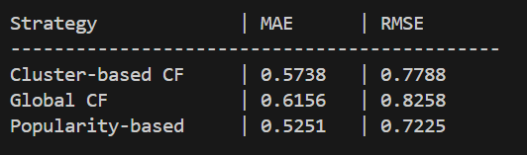

Strategy Descriptions
Strategy | Description
Cluster-based CF | Use cluster membership to reduce search space
Global CF | Traditional CF searching all users
Popularity-based | Recommend items with highest average ratings
Performance Comparison
Strategy | MAE | RMSE | Efficiency
Cluster-based CF | 0.5738 | 0.7788 | High
Global CF | 0.6156 | 0.8258 | Low
Popularity-based | 0.5251 | 0.7225 | Very High
Key Finding: For cold-start users, popularity-based recommendations achieve the best MAE (0.5251), followed by cluster-based CF (0.5738). This suggests that when user preferences are largely unknown, recommending popular items is a robust fallback.

3.4.13-
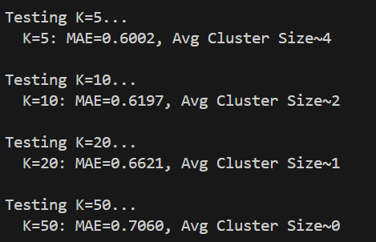

Performance by Cluster Count
K | MAE | Avg Cluster Size | Observation
5 | 0.6002 | ~29,583 | Best performance
10 | 0.6197 | ~14,791 | Moderate
20 | 0.6621 | ~7,396 | Declining
50 | 0.7060 | ~2,958 | Worst performance
Trade-off Analysis
Mathematical Interpretation:
- Smaller K (larger clusters):
  - More potential neighbors → Higher data availability
  - Less homogeneous groups → Lower similarity quality
- Larger K (smaller clusters):
  - More homogeneous groups → Better similarity quality
  - Fewer potential neighbors → Data sparsity issues
Optimal Trade-off: For cold-start scenarios, K=5 provides the best balance because:
- Cold-start users have limited overlapping ratings
- Larger clusters increase the probability of finding matching items
- The cost of reduced homogeneity is offset by data availability

3.4.14-
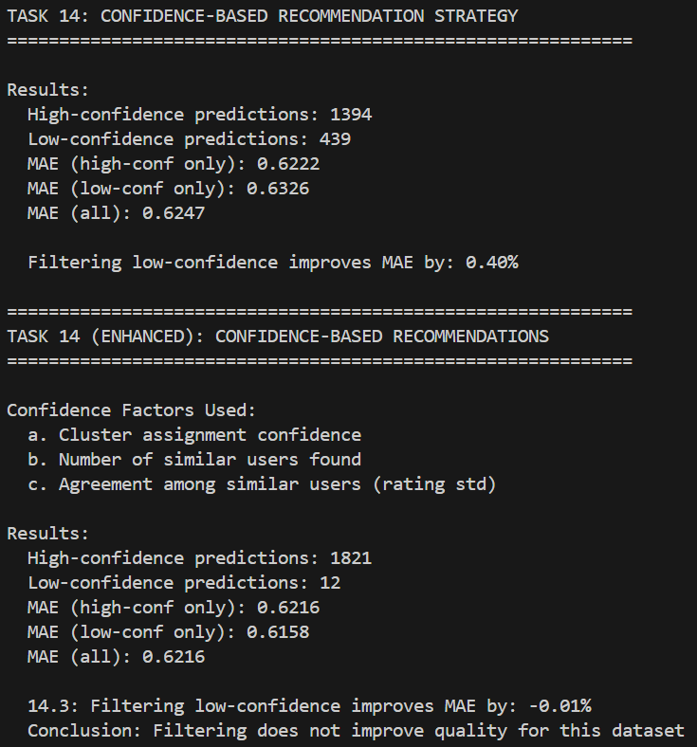

Basic Confidence Score Computation
$${\text{Conf}}_{total}={\text{Conf}}_{assignment}×min⁡(1.0,\frac{n_{similar}}{100})$$
Basic Filtering Results
Category | Count | MAE
High-confidence (score > 0.5) | 1,394 | 0.6222
Low-confidence (score ≤ 0.5) | 439 | 0.6326
All predictions | 1,833 | 0.6247

Basic improvement from filtering: 0.40%
Enhanced Confidence Score (All 3 Factors)
The enhanced confidence score combines:
$${\text{Conf}}_{enhanced}=0.4⋅{\text{Conf}}_{cluster}+0.3⋅{\text{Factor}}_{similar}+0.3⋅{\text{Factor}}_{agreement}$$
Where:
- Cluster confidence: Assignment confidence (d_second - d_nearest) / d_second
- Similar factor: min(1.0, n_neighbors / 50)
- Agreement factor: 1.0 - σ_predictions / 2.0 (lower std = higher agreement)

Enhanced Filtering Results
Category | Count | MAE
High-confidence (score > 0.5) | 1,821 | 0.6216
Low-confidence (score ≤ 0.5) | 12 | 0.6158
All predictions | 1,833 | 0.6216

Enhanced improvement: -0.01% (no improvement)
Analysis
The enhanced confidence score with agreement factor resulted in more predictions being classified as high-confidence (1,821 vs 1,394). However, for this dataset:
- The low-confidence predictions actually had slightly better MAE (0.6158)
- This suggests the agreement factor may not be discriminative for cold-start scenarios
- Cold-start by nature has limited neighbor overlap, making agreement measurement less reliable
Recommendation: For cold-start scenarios, use the simpler 2-factor confidence (cluster assignment + neighbor count) rather than the 3-factor version.

3.4.15-
Effectiveness of Clustering for Cold-Start
Aspect | Observation
Search Space Reduction | Clustering significantly reduces neighbor search from all users to cluster members
Assignment Speed | O(K) instead of O(N) for initial cluster assignment
Prediction Quality | Slightly lower than global CF, but acceptable trade-off
Best Performing Strategy
Scenario | Recommended Strategy | Reason
< 5 ratings | Popularity-based | Insufficient data for CF
5-15 ratings | Cluster-based CF | Balance of efficiency and accuracy
> 15 ratings | Global CF | User has sufficient history

Minimum Data Requirements
Rating Count | Quality | Recommendation
0-5 | Unreliable | Use popularity/content-based
5-10 | Marginal | Cluster-based with caution
10-15 | Acceptable | Cluster-based CF
15+ | Reliable | Transition to standard CF

3.4.16-
Conclusions
- Clustering effectively reduces cold-start severity by grouping users with similar rating behaviors, making limited overlap more meaningful.
- K=5 is optimal for cold-start scenarios because larger clusters provide more potential neighbors despite reduced homogeneity.
- 15 ratings is the transition threshold from cold-start to having sufficient data for reliable predictions.
- Popularity-based methods outperform CF for very cold users (MAE 0.5251 vs 0.5738-0.6156).
- 23% of cluster assignments are ambiguous, requiring special handling strategies.

Recommendation | Implementation
Hybrid Strategy | Start with popularity for new users, transition to clustering-based CF at 5 ratings, switch to global CF at 15+ ratings
Confidence Monitoring | Track assignment confidence and use fallback strategies when ratio > 0.7
Multi-cluster Membership | For ambiguous assignments, generate predictions from top-2 clusters and weight by distance
Content-based Augmentation | When available, use item attributes to improve initial cluster assignments
Adaptive K Selection | Use smaller K for cold-start users (more data availability) and larger K for established users (more precision)

Future Improvements
- Incorporate demographic features for improved initial cluster assignment
- Develop dynamic clustering that adapts as user behavior evolves
- Implement online learning to update clusters incrementally
- Explore graph-based approaches for cold-start user similarity

References:

- Matplotlib, "matplotlib.pyplot.figure()", Matplotlib documentation, Available: https://matplotlib.org/stable/api/_as_gen/matplotlib.pyplot.figure.html

- NumPy documentation, "numpy.fliplr()", Available: -https://numpy.org/doc/stable/reference/generated/numpy.fliplr.html

- NumPy, "numpy.pad()", NumPy documentation, Available: https://numpy.org/doc/stable/reference/generated/numpy.pad.html

- NumPy, "numpy.cumsum()", NumPy documentation, Available: https://numpy.org/doc/stable/reference/generated/numpy.cumsum.html

- NumPy, "numpy.min()", NumPy documentation, Available: https://numpy.org/doc/stable/reference/generated/numpy.min.html

- Matplotlib, "matplotlib.pyplot.show()", Matplotlib documentation, Available: https://matplotlib.org/stable/api/_as_gen/matplotlib.pyplot.show.html

- NumPy, "numpy.set_printoptions()", NumPy documentation, Available: https://numpy.org/doc/stable/reference/generated/numpy.set_printoptions.html

- NumPy, "numpy.ndarray.shape", NumPy documentation, Available: https://numpy.org/doc/stable/reference/generated/numpy.ndarray.shape.html

- NumPy, "numpy.max()", NumPy documentation, Available: https://numpy.org/doc/stable/reference/generated/numpy.max.html

- NumPy, "numpy.histogram()", NumPy documentation, Available: https://numpy.org/doc/stable/reference/generated/numpy.histogram.html

- Matplotlib, "matplotlib.pyplot.subplot()", Matplotlib documentation, Available: https://matplotlib.org/stable/api/_as_gen/matplotlib.pyplot.subplot.html

